**Project Name:** Hotel Aurora

**Motto:** To provide best hotel booking and Info service

**Team Name:** Thunderstruck

**Team Members**: Azizbek Kobilov (Backend Dev.)

Akmal Karimov (Design, front-end)

Dostonjon Sukhrobov (3d Builder, front-end)

Feruza Latipova (Front-end)

Mirkamol Khamidov(Front-end)

<http://hotelaurora.cf>

https://github.com/iuthub/design-project-thunderstruck

LINK TO GITHUB

**Brief Description:** So our web site provides users with hotel information and online-booking system to get necessary info about the hotel easily to have a good time in there and see one of the most beautiful natural phenomenal Northern Lights (Aurora). The web site is comfortable to use and enables users to get contacted and reserve room without wasting time in luxurious yet affordable hotel. On the main page user can find brief info about rooms, restaurants and Glass-igloos and on the sidebar user can find additional info. Also for user visualization, we provided 3d view of our Hotel. Also, our web-site is totally responsive.

Main Functionality:

So as you see our project is hotel web site, so it has booking system. Technologies used: Laravel 5.6, PHP 7.1, MySQL, React and external weather service. Landing page is created using React and API provided by Laravel, and also in the footer we have weather which comes from Laravel controller as external website API. This is all gathered and rendered in React mainpage.js component. Also we have comments which publishes comments asynchronously, using also React. Other pages are created by using Laravel itself.

One more feature is 3D view, which is not included because of big sizes(hosting does not support), but we can share you by flashcard, if you need.

How to use:

Click booking button, enter info, and you will go to page where you can find all available rooms for you. Then you press any available room, then you fill all data. That’s is for booking, pretty simple.

Admin page is accessible by the link:

/admin

Login: admin

Password: admin123

We didn’t have time to complete admin page, we should make page to see bookings and comments. But problem with time. But as you look to our controllers and views, you can realize that we can do it easily.

Here you can find some screenshots of admin page and then website itself.

Actually you can see our web site by the link: <http://hotelaurora.cf>

If there is no enough screenshots.

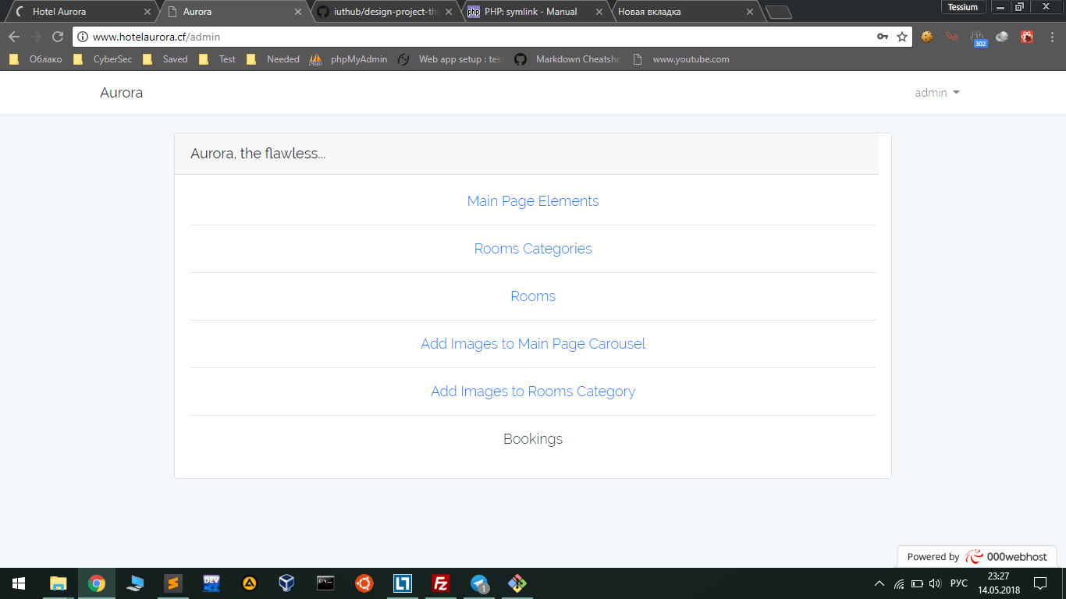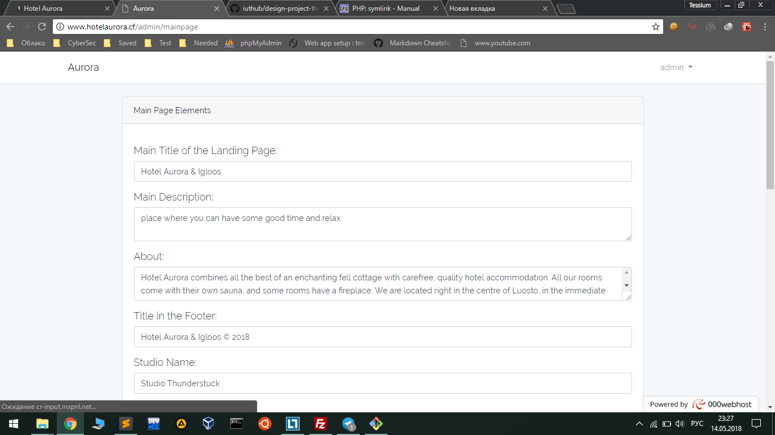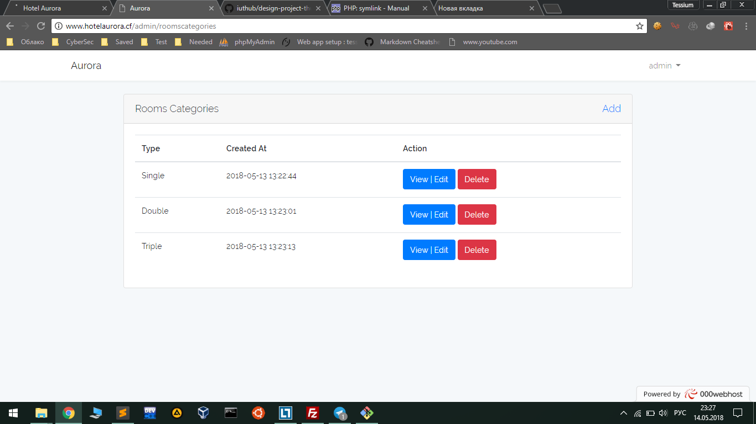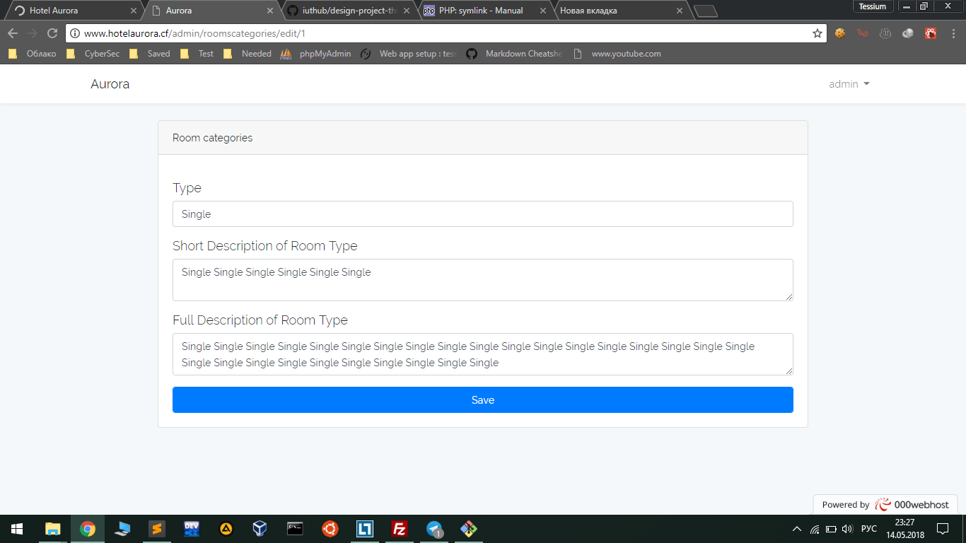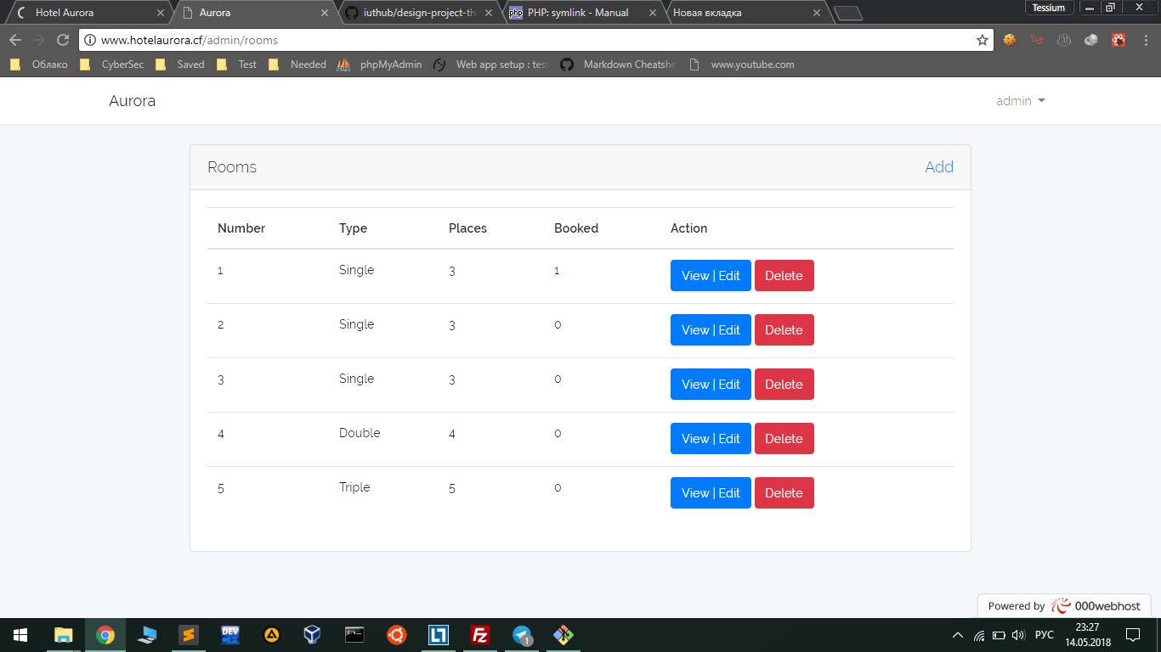

**Main Pages:**

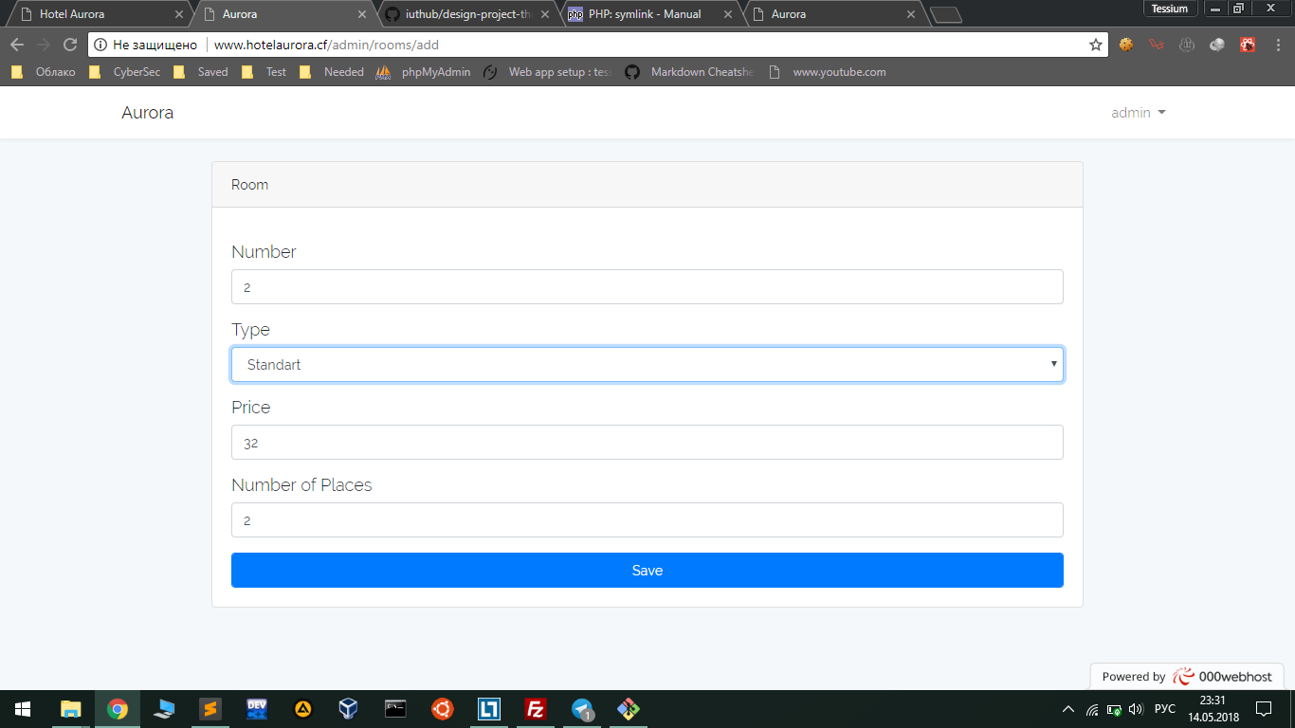

**Front-end:** Our pages are done on bootstrap 4, HTML5 and CSS3 and font awesome for icons . On the other hand, our page are full page scrollable. If you scroll, it moves by page, which is comfortable. For that, we used plugin Fullpage.js.

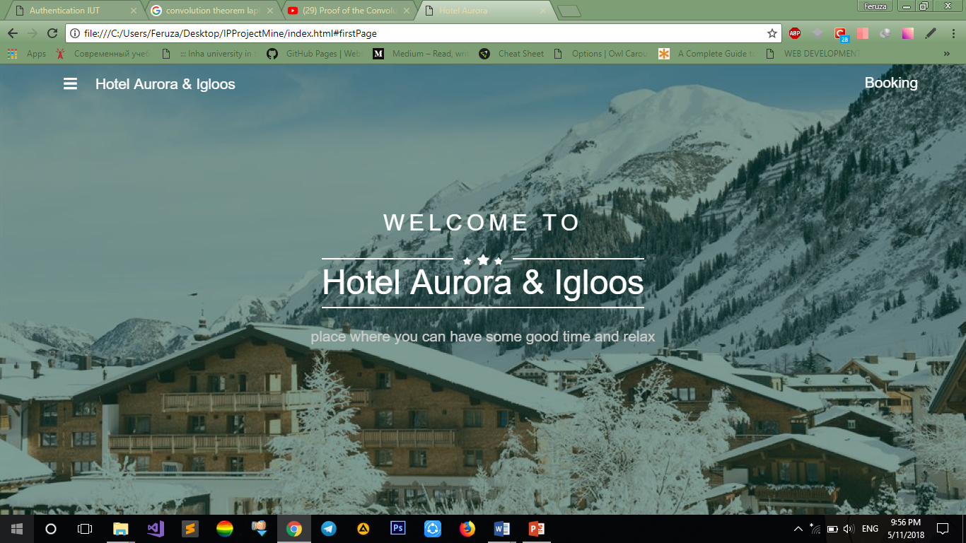

This is our landing page. On navigation, you can see hamburger, brand name and booking button and it is sticky-top. If you press hamburger (menu icon) you can see links to the pages for additional pages. For that, we also used two Js: functions openNav() and closenav(). When you open sidebar everything margins to right.

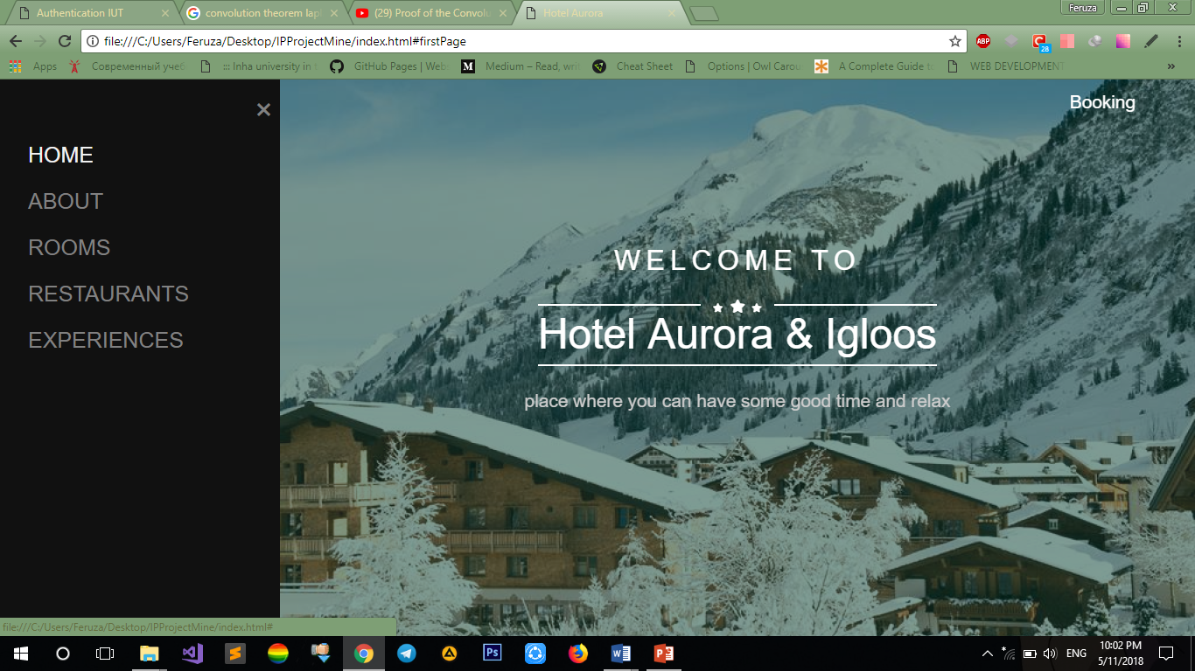

Also if you press button “Booking” it will provide you main searching systems for rooms which is available. Which is modal. Also, here main role is Js . We used EventHandler window.onclick and when we click it displays our booking sytem.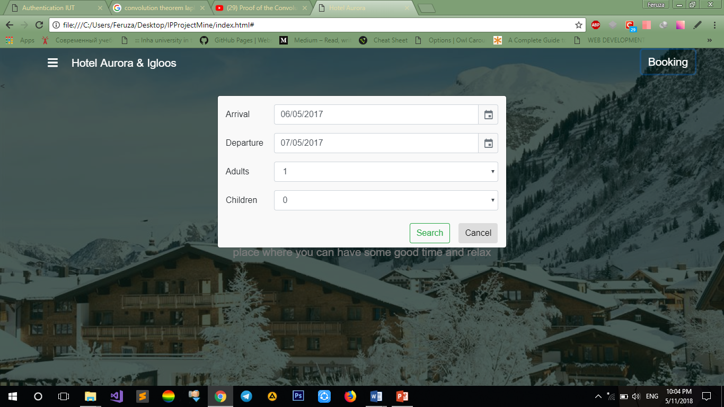

Another feature, for user conveniences they will choose arrival and departure date via calendar. Also they are usable not for only main page but in another pages. 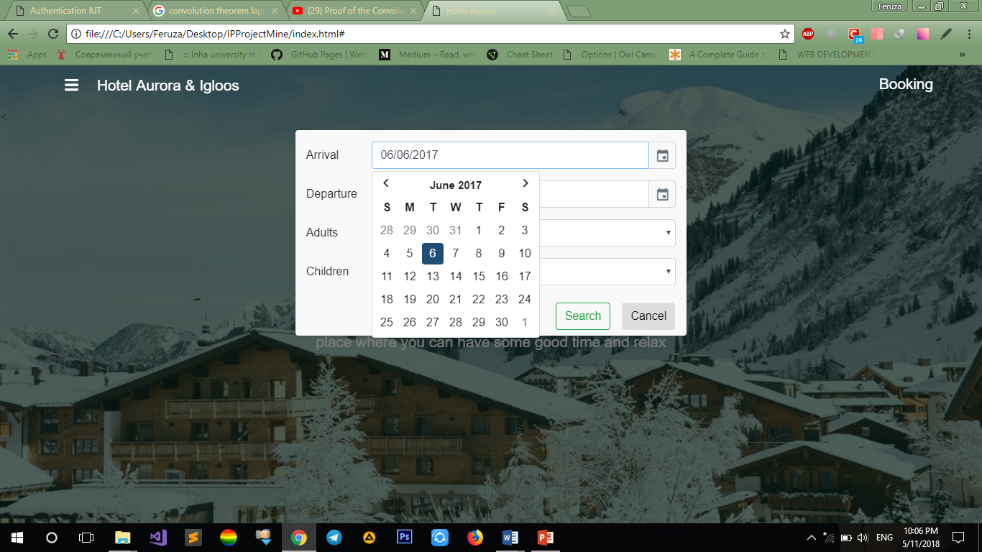

If users changes mind they push cancel button or just press somewhere else and booking model will be closed.

The second page is About Page and via button of 3d View of hotel user finds view of Hotel in 3d version.When you scroll to the second page our nav bar changes color and sticks at top.

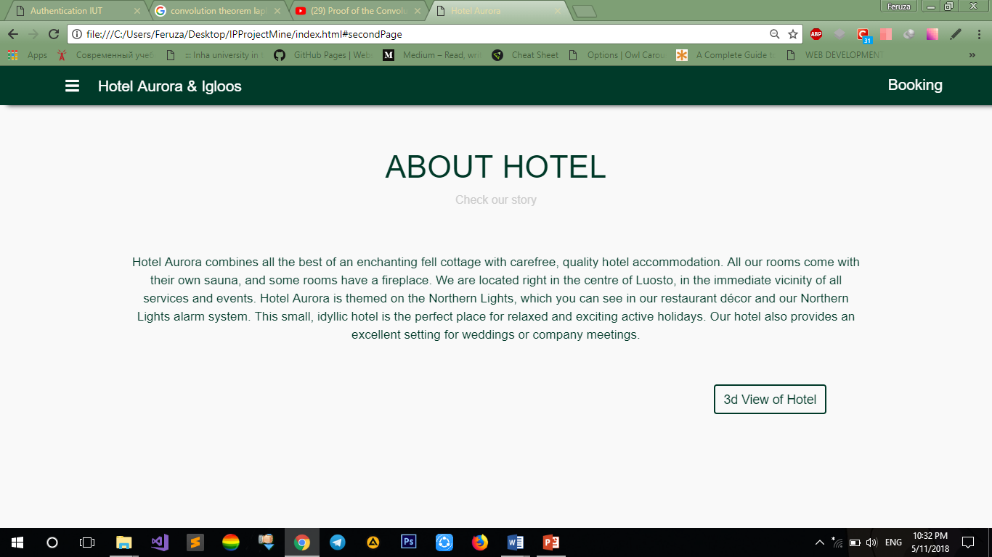

3D part of the website is created with a help of the libraries of "three.js" and browsers are able to render it with WebGL. The code of website included the libraries of "js" internally ("as we needed to host we relied on only one static "html" file") therefore the whole libraries and textures are included in only one static file.

How it works:

It launches on any browser even on "Microsoft edge" no need for plugins.

After opening the page user will have full 3D environment apartment where he\she can walk around (as games).

Also VR mode can be accessed with mobile version of web application + sharing links for Facebook, Twitter and others included.

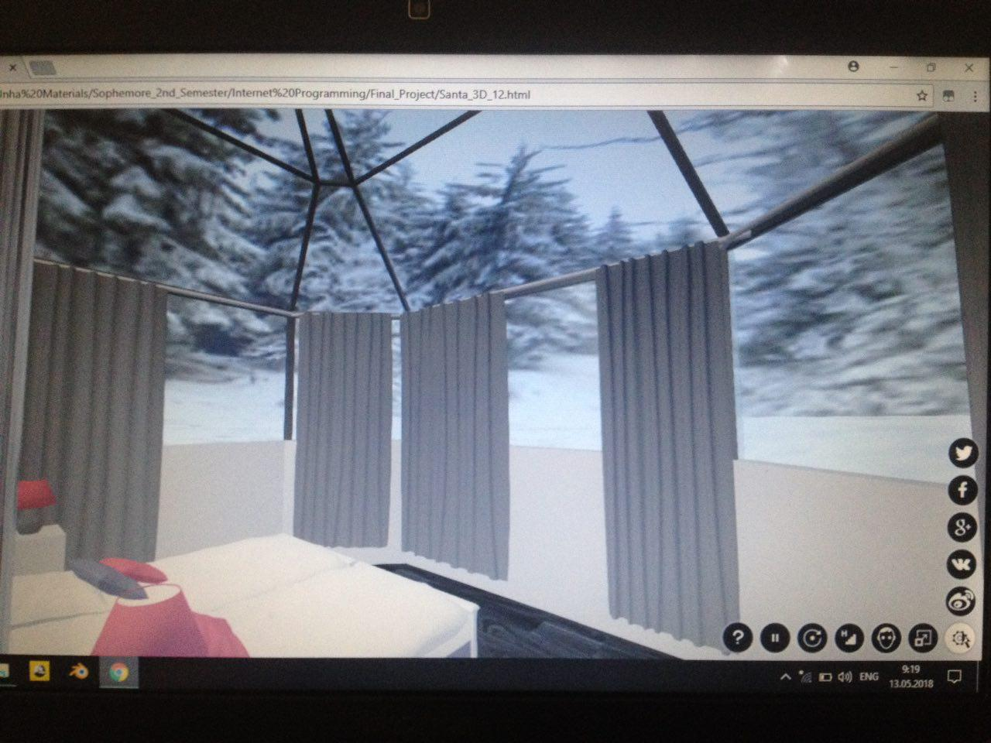

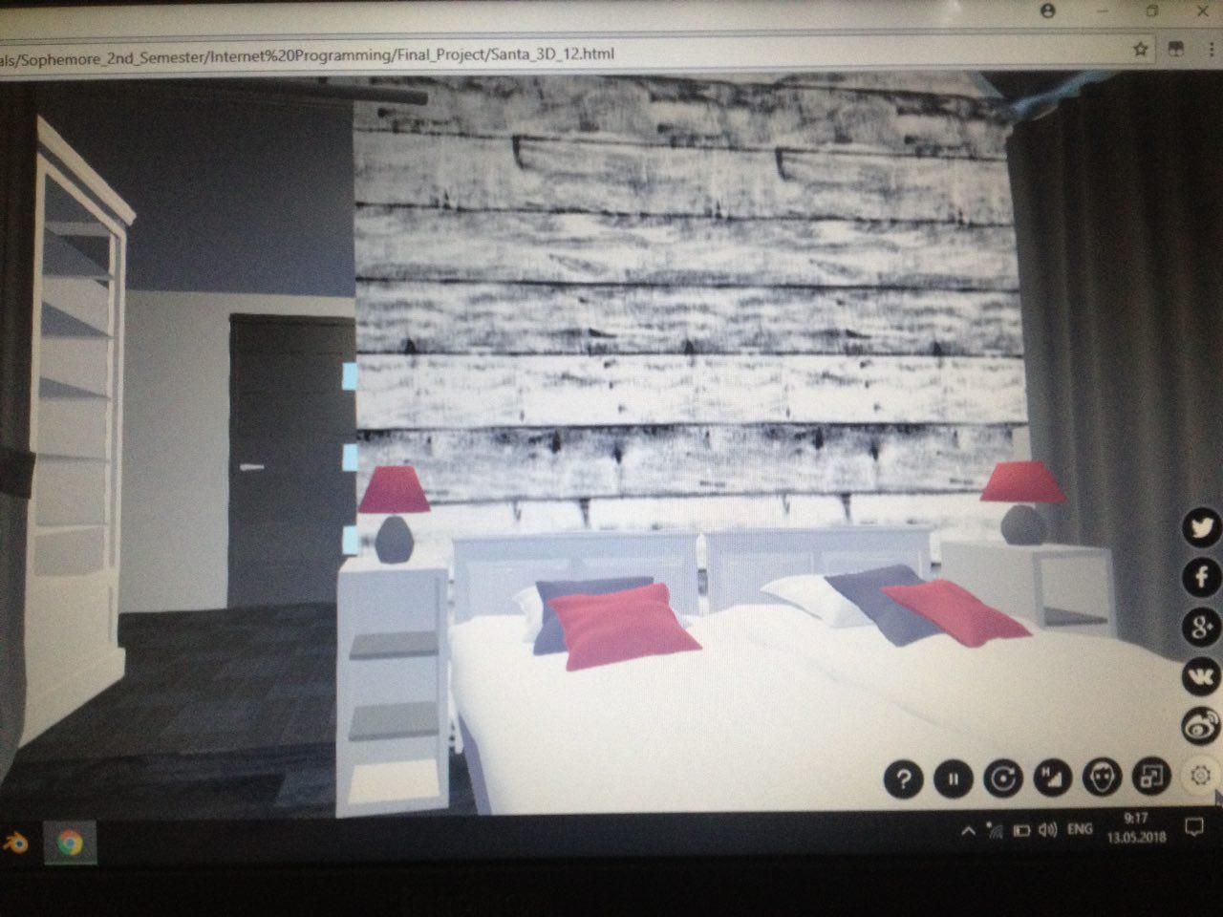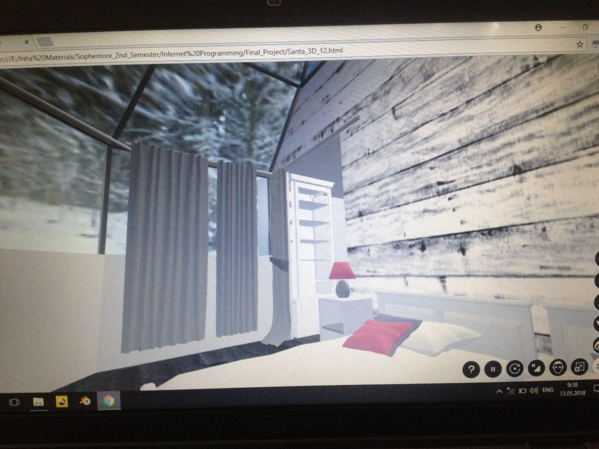

Services is on our third scroll-part. Here you can find info and carousel of pictures about rooms, restaurants and Glass-Igloos. By auto, first page is about rooms but if you press next-icon, you can see info about Restaurants, then Glass Igloos. For carousel we used plugin swiper. And also there is horizontal carousel which is another feature of fullpage.js.

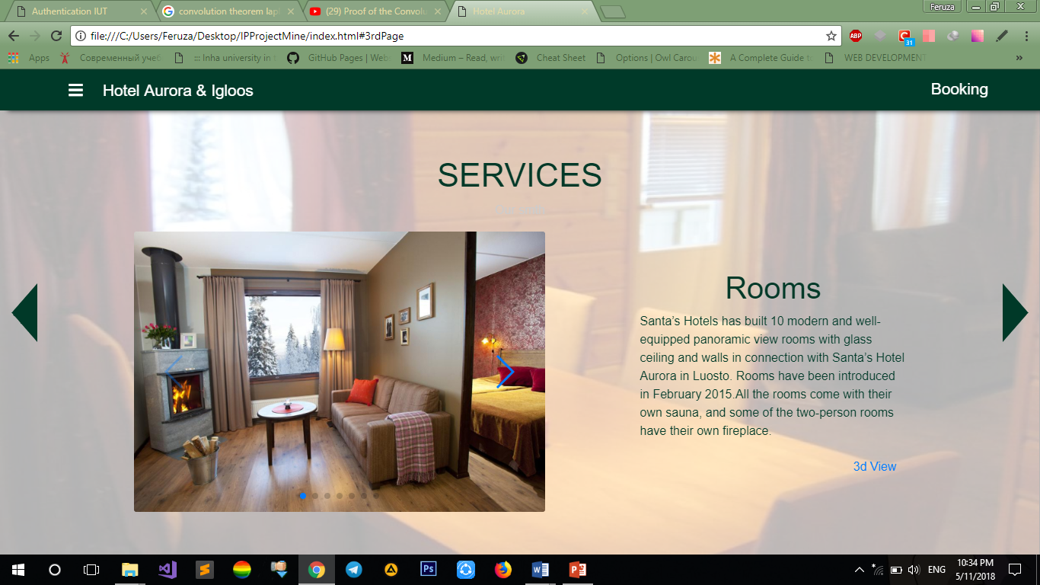

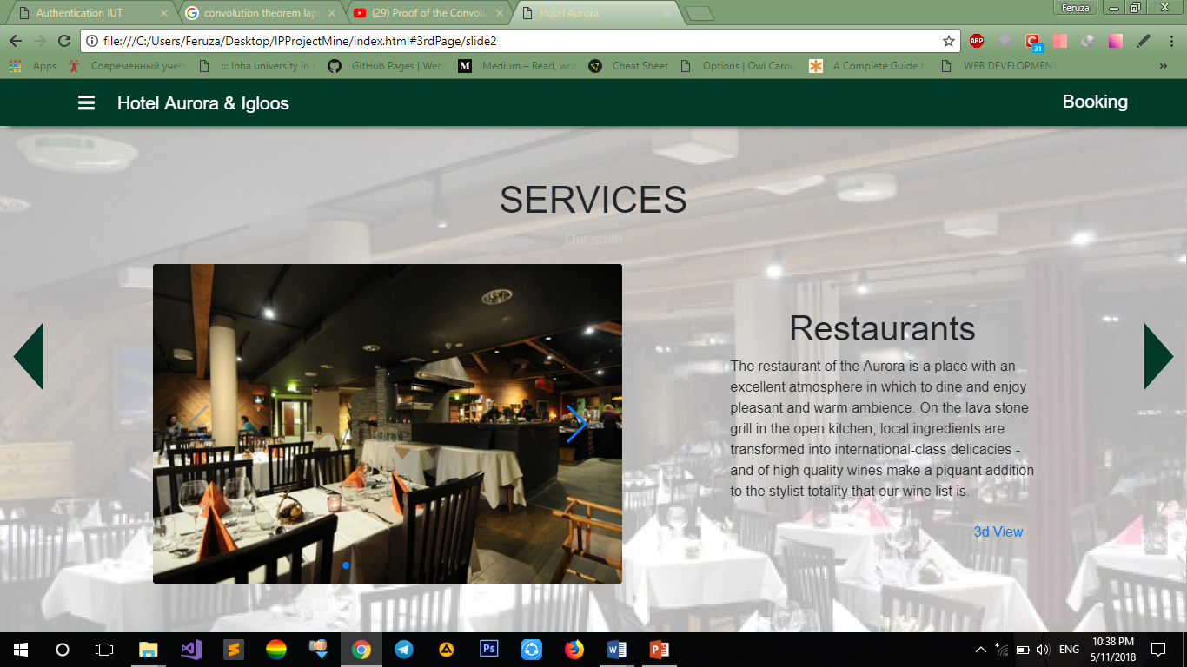 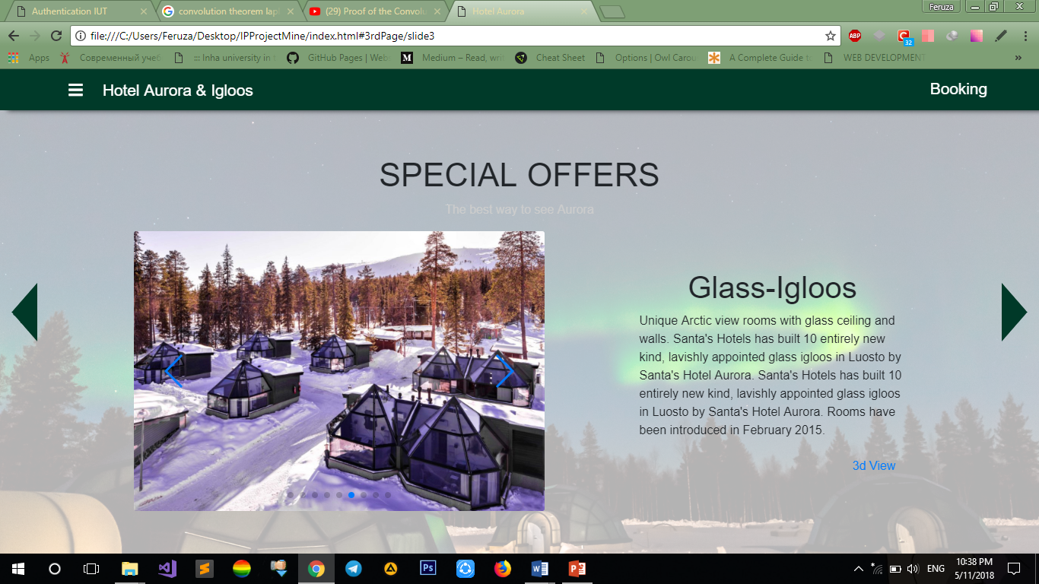

And last one is our footer on the right side can contact with hotel, leave message. And weather forecast which takes data API. On the left side address and contact also, google map, which helps to find our Hotel. Also we provide links for social media.

**After searching room**:

In completely another page we come up with view off available rooms per night for several days between the period which was entered by client user.

So we have almost the same navbar at the top of the. For menu there we used jQuery.

We have Carousel made with using CSS and Bootstrap right after the navbar where we can move through available rooms within the particular period of time

Then we have list of rooms with image and brief description of each one. There is a button near the description which helps to go to the next stage of booking (new page).

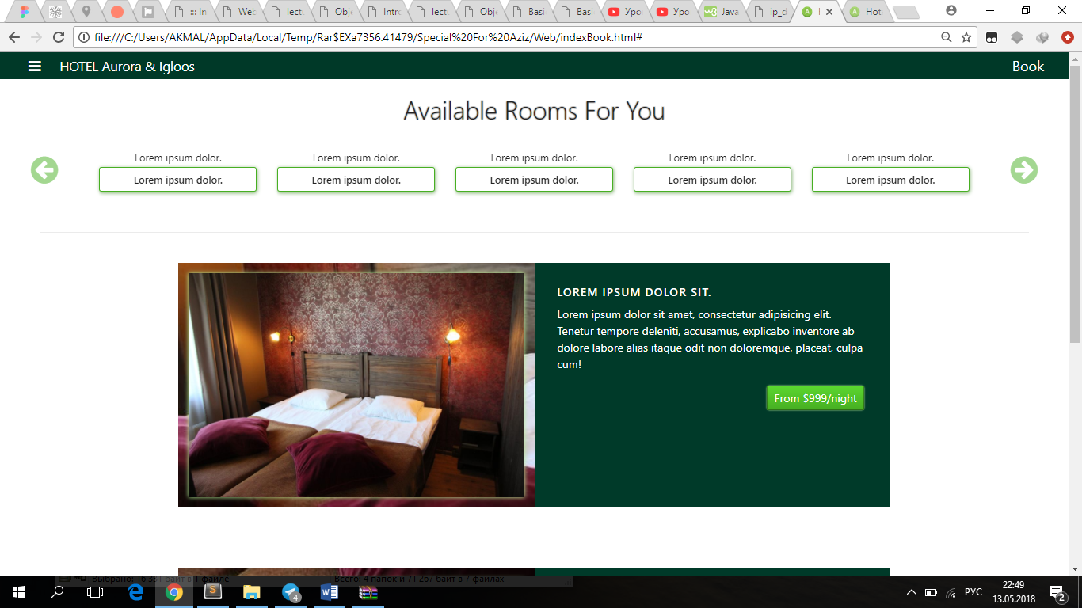

Finally, the short footer with necessary information.

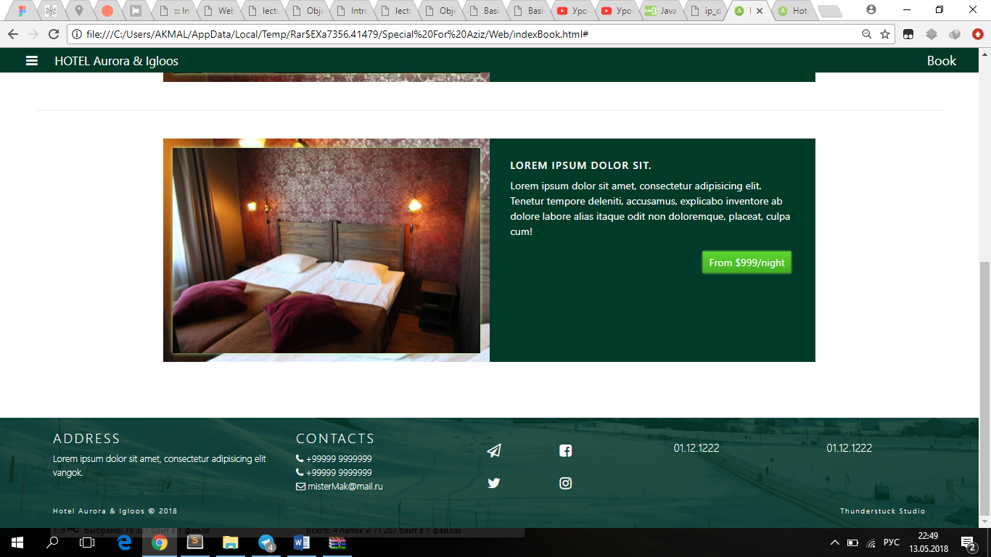

The page below is actually used by client for Completion of the Form providing all necessary data after choosing the room where its description with photo is stored right to the form.

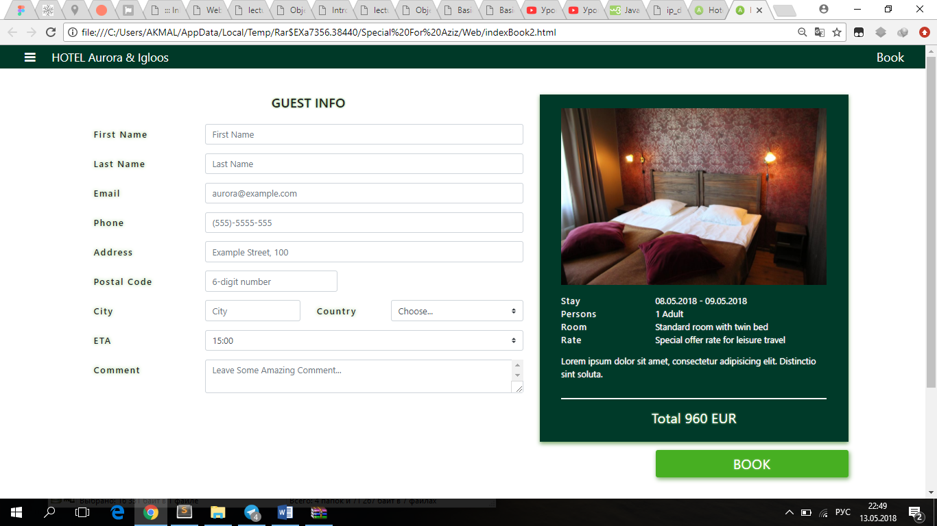

The next page involves the whole information with all photos of rooms, with interactive carousel of images placed first on the top of page after the navbar. Then we have a full description of rooms.

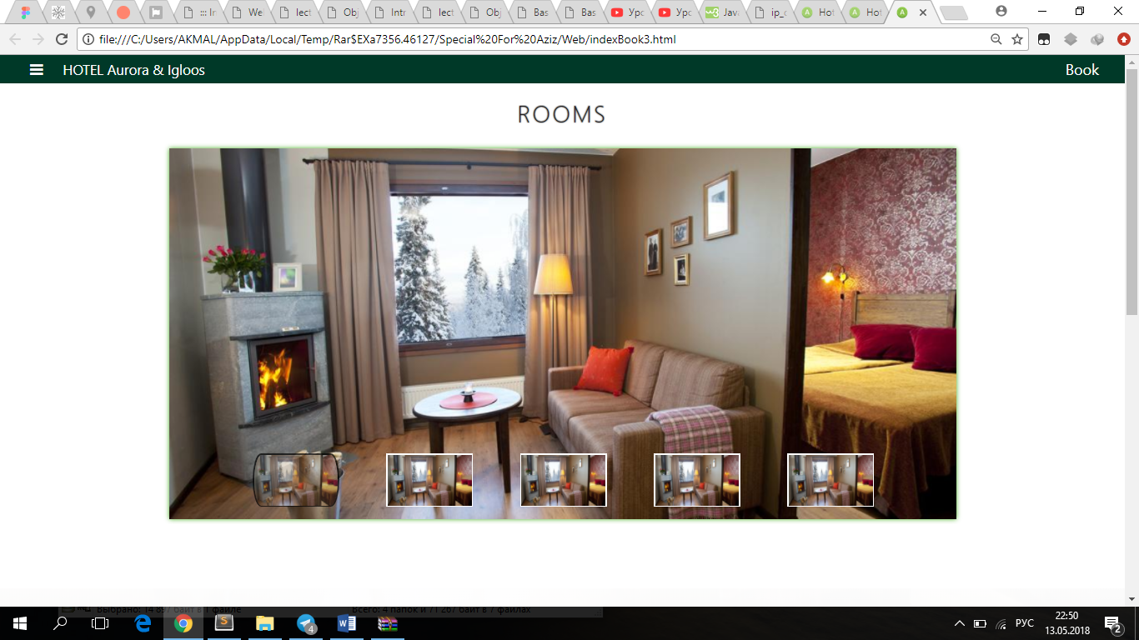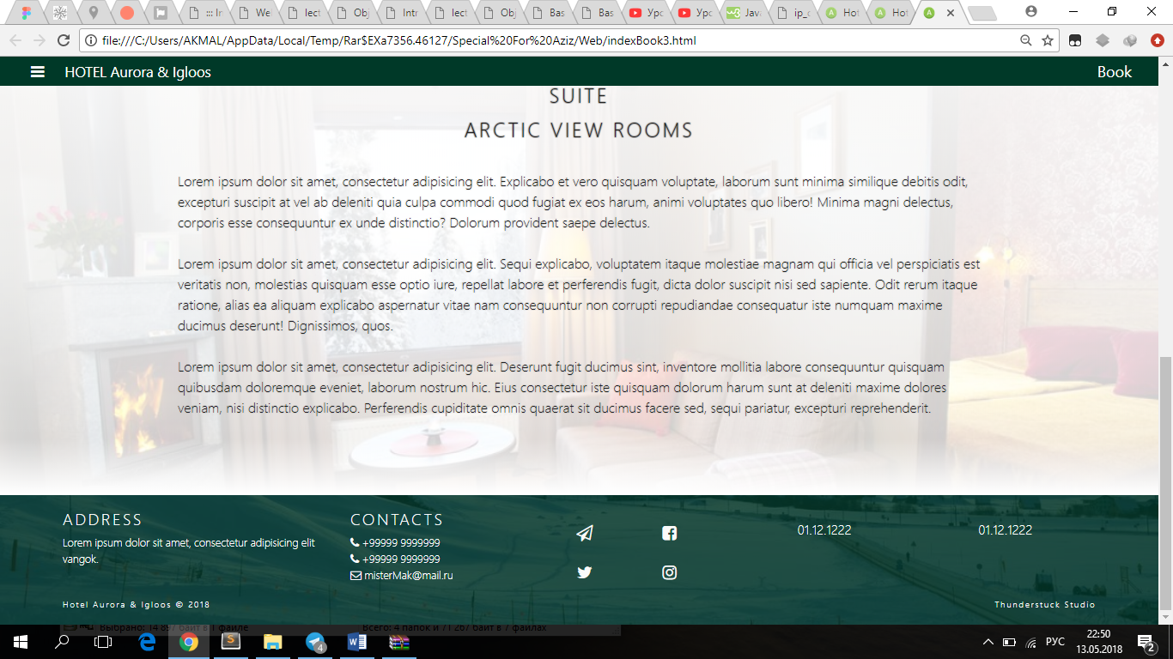

The website was made in interactive manner being user friendly for our clients with all elegantly made components such as buttons, form inputs, background images, gradients and etc.

Contribution of Members:

Azizbek Kobilov => Backend + React + External API

Akmal Karimov => Design of all pages and Front-End

Dostonjon Sukhrobov => 3D module and Front-End

Feruza Latipova (Front-end) => Landing page

Mirkamol Khamidov(Front-end) => Search page, Book page, Room page